Flow viscosity cup (IWATA NK-2 cup)
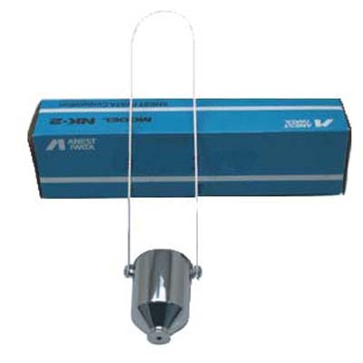
Description
Based on Japanese method of liquid viscosity measure, this cup is used to test viscosity liquid flow through the taper orifice with interior diameter of 50mm and exterior diameter of 86 mm.
Note: The Iwata cup is based on measuring the flow of liquid in seconds. A precision stopwatch is necessary.
Technical data sheets
Scientific name IWATA NK-2 cup
Int. vertical height (mm) 430±0.1
Int. orifice (mm) Φ3.81±0.05
Ext. orifice (mm) Φ6.0±0.5
Centistokes range 70-370
Efflux time (sec) 20-105±0.2s
Details of IWATA Cup
Int. diameter (mm) 50±0.05
Ext. diameter (mm) 86±0.1
Int. orifice length (mm) 10±0.1
Operating Temperature (℃) 0-50±0.2

